**Benchmark of YouFood**

Introduction:

## Mobile apps in the Food and Drink category have experienced radical change these last few weeks. The COVID-19 pandemic has more and more people using app-based food delivery services, and QSRs are seeing an influx of mobile payments at their [drive-throughs](https://www.apptentive.com/blog/2019/05/22/best-qsr-apps-fast-food-mobile-ordering-examples/) with the closure of dine-in establishments. For example, [according to data](https://www.fool.com/investing/2020/03/20/quick-service-eateries-see-an-11-traffic-boost-fro.aspx) compiled by picaxel, QSR foot traffic increased 11 percent from mid-February to mid-March in the Morocco.

## The average of Food and Drink:

The average Food and Drink app’s New or Repeat Fans (iOS 56%, Android 61%) fall slightly below the general average (iOS 58%, Android 65%); New or Repeat Risks (iOS 34%, Android 34%) are higher than the general average (iOS 32%, Android 28%); Fans Shifted to Risks (iOS 5%, Android 2%) are roughly the general average (iOS 5%, Android 3%); and Risks Shifted to Fans meet the general average (both show iOS 5%, Android 3%).

The data tells us there is more at stake for Food and Drink apps when it comes to encouraging [customer love and brand loyalty](https://www.apptentive.com/blog/2019/06/18/how-major-brands-use-mobile-customer-loyalty-programs/). The Food and Drink category is extremely competitive and dynamic in a way other app categories are not – especially right now. There’s always another delivery app or loyalty program trying to lure customers away, especially for QSR brands.

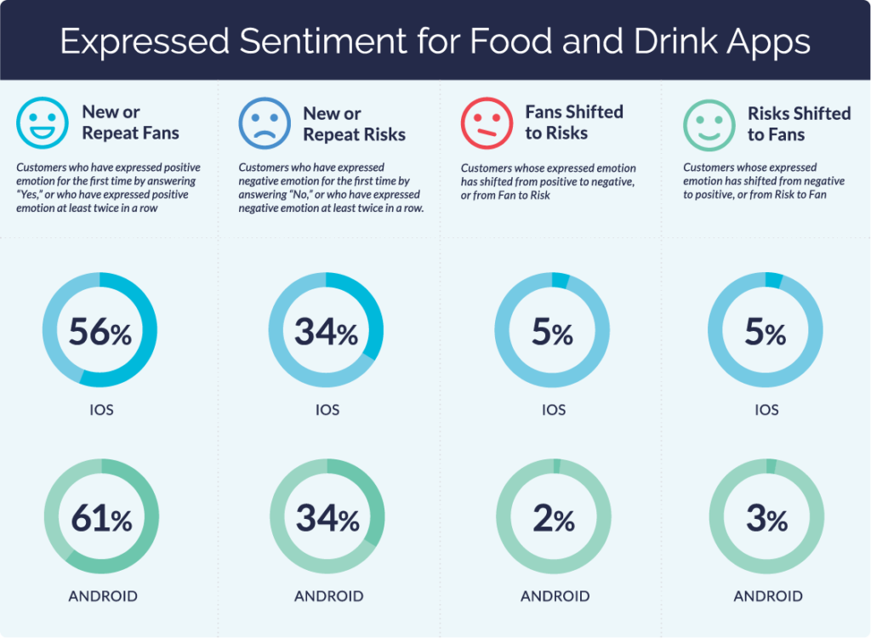

Mobile Retention and Loyalty

Looking at retention, Food and Drink apps ended the year with an average of 37% of new consumers retained, which is lower than the general average of 43%. Again, we believe the lower retention numbers have to do with fierce competition within the category and how to keep customers engaged. Loyalty programs provide QSR apps an effective and efficient tool to incentivize customers to place repeat orders, but many offers are flash deals like $1 food and drinks to encourage customers to buy more right away. These deals may work in the short-term, but they aren’t great for retaining customers over time.

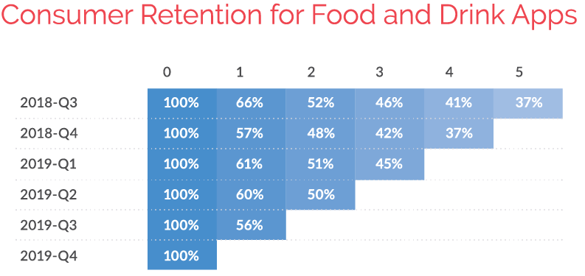

App Ratings and Reviews

78% of the average iOS Food and Drink app’s ratings were five-stars, and 7% were one-star. Android apps in the same category showed 56% of their ratings as five-stars, and 23% of their ratings as one-star. Food and Drink apps tend to be more transactional than apps in other categories. Consumers notice small in-app changes right away, where they might not see them otherwise.

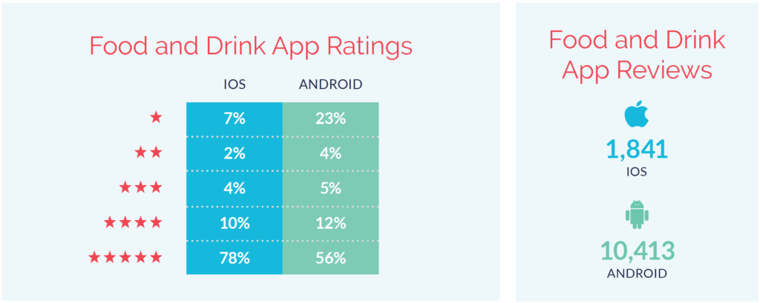

iOS apps in the Food and Drink category saw an average of 1,841 reviews, where Android apps saw an average of 10,413. Below are the averages for Food and Drink app interaction and response rates, surveys, and in-app messages.

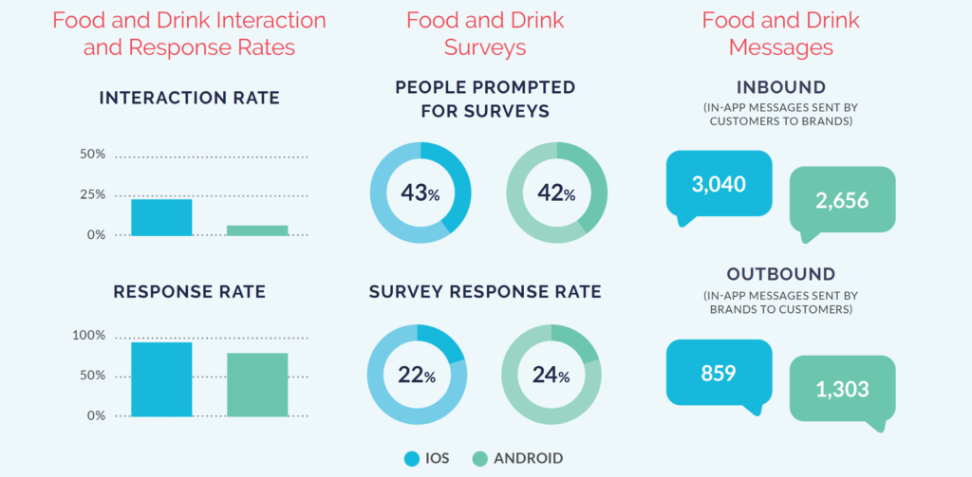

Exemple Dinning App

